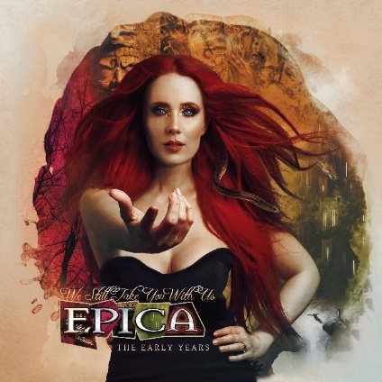

EPICA
»We Still Take You With Us«
+
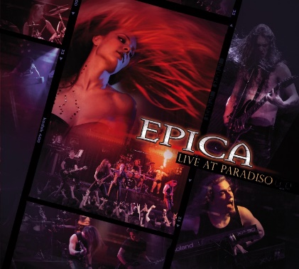
»Live At Paradiso«

Release: September 2, 2022

Line up: | EPICA online:
Simone Simons | Vocals  Mark Jansen | Guitars & Growls  Isaac Delahaye | Guitars  Coen Janssen | Synth & Piano  Ariën Van Weesenbeek | Drums  Rob Van Der Loo | Bass | www.epica.nl  www.facebook.com/epica  www.twitter.com/epica  www.instagram.com/epicaofficial
2022 marks the 20th anniversary of Symphonic Metal titans EPICA. After nearly 1 million albums sold worldwide and over 300 million combined streams on all digital platforms, the Dutch band has manifested their talent to combine metal with unique operatic vocals and has gained a huge international fanbase in the process. Through their career EPICA have played over 1,000 shows in more than 60 countries across all continents.
With their latest musical output “Omega”, the band achieved Top 5 placements in the album charts of several countries such as Germany and Switzerland, but now they look to their past:
On September 2nd, EPICA will re-issue their first three albums “The Phantom Agony”, “Consign To Oblivion” and “The Score”, which have become milestones of the genre and rarities within the physical market. Each record will be available in either a CD box, a collector’s LP box or as an earbook and each will come with previously unreleased bonus tracks for each album. As a special surprise for their fans, the band have dug up some spectacular hidden gems from their early career that will be available as bonus material on some of the formats.
“Live At Paradiso” - Initially recorded in 2006 at the beautiful “Paradiso” venue in Amsterdam, the performance has become shrouded in legend; often scheduled for release, this will be the first time it’s seen the light of day. The recording allows fans to relive the memories of a young band who had just freshly released their two first albums, and features a number of their evergreen hits like ‘Cry For The Moon’ or ‘Solitary Ground’. Now, after being hidden away in a dark drawer for more than 16 years, “Live At Paradiso” is finally available on 2CD and BluRay/DVD - specifically revamped in 4K resolution.
“We Will Take You With Us”
Recorded at the ‘Twe Meter Sessies’ on public Dutch TV, most hardcore fans will be familiar with this release that was the band’s first major performance on television and first DVD release that has long been sold out. You can also discover two especially rare demo recordings from SAHARA DUST – the band that should later become EPICA.
The following formats will be available on September 2nd:
- 11 Disc Boxset on black vinyl, transparent blue vinyl (wholesale exclusive) and gold vinyl (bandshop excl.), including:
The Phantom Agony 2LP, We Will Take You With Us 2LP, Consign To Oblivion 2LP, The Score 2LP, Live At Paradiso 3LP

- Earbook with 36 pages and 8 discs:
The Phantom Agony, We Will Take You With Us, Consign To Oblivion, The Score, Live At Paradiso 2CD, BluRay and DVD

- CD Box in clamshell including 4 discs: The Phantom Agony, We Will Take You With Us, Consign To Oblivion, The Score

- Live At Paradiso 2CD + BluRay

- Live At Paradiso + We Will Take You With Us will also be available as download and stream
After just concluding a successful headline tour through Mexico, EPICA will return to Europe to perform at several summer festivals before embarking on a North America Tour in September 2022 with Sabaton, a Latin American headline Tour in November and an extensive run through Europe in early 2023 with Apocalyptica. All upcoming dates can be found at www.epica.nl

